Energy Budget for Stream Temperature Using SNTemp Output

Jake Zwart (with input from others); 2019-10-01

**Energy budget**

Stream temperature (*Tw*) can be calculated using an energy mass balance model which accounts for the effect of inflows (upstream, groundwater, surface runoff), outflows, and surface heating and cooling on heat transfer in each stream segment (Herbert et al. 2011, Cole et al. 2014):

$\frac{∂T_{w}}{∂t}= \frac{W*H_{n}}{c_{w}ρ_{w}A}*86400sec/day$ (1)

where *Hn* is the rate of change of heat stored in the stream segment (W m-2), *A* is stream segment cross-sectional area (m2), *W* is the stream segment width (m), $ρ_{W}$ is the density of water (1000 kg m-3), and is the specific heat of water (4186 J kg-1 deg C-1). The energy budget for each stream segment is formulated as:

$H_{n}=H_{a}+H_{v}-H_{w}+H_{s}-H_{e}-H_{c}+H_{d}+H_{f}+H_{u}$ (2)

Where *Hn*  is the net heat flux into the stream, *Ha* is the flux from atmospheric-emitted longwave radiation, *Hv* is the longwave radiation emitted by riparian vegetation, *Hw* is the longwave radiation emitted by the water, *Hs* is the net flux from shortwave solar radiation, *He* is the evaporation heat flux from the latent heat of vaporization, *Hc* is the conductive and convective heat transfer at the air–water interface, *Hd* is the heat flux from conduction at the water– streambed interface, *Hf* is the heat dissipated from potential energy by friction, and Hu is the net heat advected into each stream segment (e.g. upstream inflow, groundwater). All units are in W m-2.

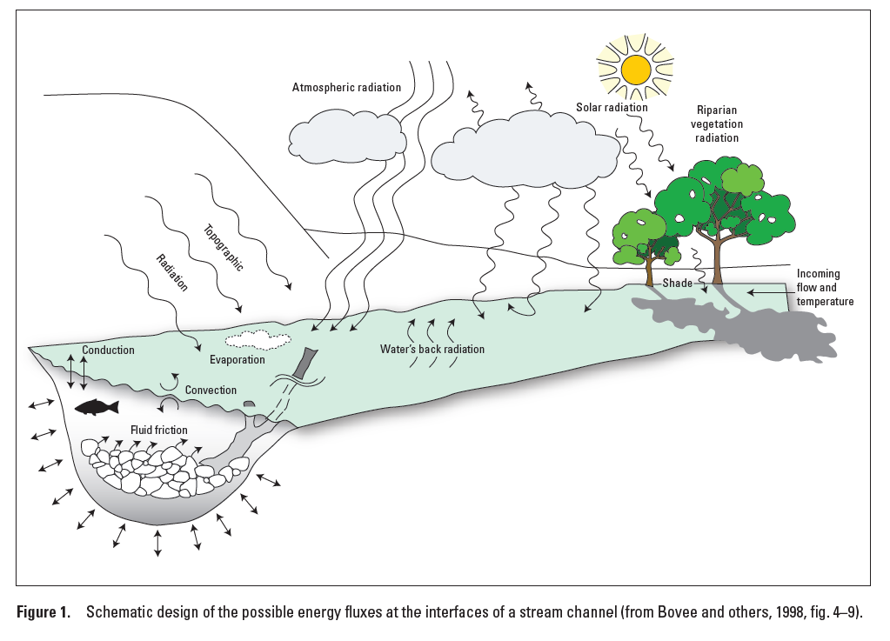

Figure from Sanders et al. 2017.

***Radiative heat fluxes***

Daily average atmospheric longwave radiation, *Ha* (W m-2), is calculated as:

$H_{a}=\left(1-r_{l}\right)\left(1-Sh\right)\left(1+0.17C_{l}^{2}\right)ε_{a}σ{\left(T_{a}+273.16\right)}^{4}$

where *rl* is the longwave reflection fraction (assumed to be 0.0), *Sh* is the shade fraction (*seg_shade* variable in SNTemp output), *Cl* is the decimal cloud fraction (*seg_ccov* variable in SNTemp output), *σ* is the Stefan-Boltzmann constant (5.6697x10-8 W m-2 K-4), *Ta* is the air temperature (degrees C, *seg_tave_air* variable in SNTemp output), and *ɛa* is the emissivity of air calculated as:

$ε_{a}=0.61+0.05\sqrt{e_{a}}$

where *ea* is the vapor pressure (millibars) of air calculated as:

$e_{a}= RHe_{s}$

$e_{s}=6.11exp\left[\frac{17.27T_{a}}{273.16+T_{a}}\right]$

where *RH* is the relative humidity (decimal fraction, *seg_humid* variable in SNTemp output).

Riparian vegetation emits some longwave radiation, *Hv* (W m-2), and is calculated as:

$H_{v}=ε_{v}σ{Sh}_{v}{\left(T_{a}+273.16\right)}^{4}$

where *εv* is the emissivity of the vegetation (0.9526), and *Shv* is the shade fraction from riparian vegetation (not sure what variable this would be in SNTemp).

The stream emits longwave radiation, *Hw* (W m-2), and is calculated as:

$H_{w}=ε_{w}σ{(T_{w}+273.16)}^{4}$ (4)

Where *εw* is the emissivity of the water surface (0.97, dimensionless), $σ$ is the Stefan-Boltzmann constant (5.6697x10-8 W m-2 K-4), and *Tw* is the stream water temperature (degrees C, *seg_tave_water* variable in SNTemp output).

Incoming shortwave radiation, *Hs* (W m-2), is calculated as:

$H_{s}=\left(1-α_{sw}\right)\left(1-Sh\right)SW$

where 𝛼sw is the shortwave albedo of water (set to 0.1 in SNTemp), and *SW* is the clear sky shortwave radiation (W m-2, *seginc_swrad* variable in SNTemp output).

Evaporative heat flux, *He* (W m-2), is calculated as:

$H_{e}=λE⋅ρ_{W}$

where *E* is the free-water surface-evaporation rate and assumed to be potential evaporation (m s-1, *seg_potet* variable in SNTemp output), $ρ_{W}$ is the density of water (1000 kg m-3), and is the latent heat of vaporization (J kg-1) and is calculated as:

$λ=2495⋅ρ_{W}-2360T_{w}$

Heat is exchanged by air circulation as convective heat flux, *Hc* (W m-2), and is calculated as:

$H_{c}=BoH_{e}$

where

$Bo=B_{c}\left(T_{w}-T_{a}\right)$

and the Bowen Coefficient, *Bc* , is:

$B_{c}=\frac{0.00061⋅P}{\left(e_{s}-e_{a}\right)}$

where *P* is the atmospheric pressure (millibars, based on segment elevation *seg_elev*) and estimated as:

$P=\left(\frac{1}{mmHg2mb}\right)⋅mmHg2inHg⋅P_{sea}⋅exp\left[\frac{-A_{g}⋅M_{a}⋅Elev}{R⋅T_{sea}}\right]$

where *mmHg2mb* is unit conversion (0.750061683), *mmHg2inHg* is unit conversion (25.3970886), *Psea* is standard pressure at sea level (29.92126), *Ag* is acceleration due to gravity (9.80665), *Ma* is the molar mass of air (0.0289644), *Elev* is the stream segment elevation (m, from *seg_elev* in SNTemp output), *R* is the universal gas constant (8.31447), and *Tsea* is the standard temperature at sea level (288.16 K).

Streambed conduction, *Hd* (W m-2), is calculated as:

$H_{d}=\left(\frac{K_{g}\left(T_{g}-T_{w}\right)}{\hat{Z}}\right)$

where *Kg* is the thermal conductivity of the streambed (assumed to be 1.65 in W m-2 C-1), *Tgw* is the groundwater temperature (C, *seg_tave_gw* variable in SNTemp output), and $\hat{Z}$ is the equilibrium depth, in meters, from the water–streambed interface at which the temperature is *Tgw* (assumed to be 1.0).

Stream friction, *Hf* (W m-2), is calculated as:

$H_{f}=9805\frac{QS_{f}}{W}$

where *Q* is the stream discharge at top of reach (m3 s-1, *seg_upstream_inflow* variable in SNTemp output), *Sf* is the stream gradient (dimensionless, *seg_slope* variable in SNTemp output), and *W* is the stream width (m, *seg_width* variable in SNTemp output).

Net heat advected, *Hu* (W m-2), into each stream segment through water was calculated as the sum of heat transfer from all water fluxes:

$H_{u}=H_{rain}+H_{GW}+H_{upstream}+H_{sroff}+H_{ss}-H_{outflow}-H_{evap}$

Where:

$H_{rain}=ρ_{W}×c_{W}×seg_rain ×seg_width×seg_length ×seg_tave_air÷86400$

$H_{GW}=ρ_{W}×c_{W}×seginc_gwflow×seg_tave_gw$

$H_{upstream}=ρ_{W}×c_{W}×seg_upstream_inflow×seg_tave_upstream$

$H_{sroff}=ρ_{W}×c_{W}×seginc_sroff×seg_tave_sroff$

$H_{ss}=ρ_{W}×c_{W}×seginc_ssflow×seg_tave_ss$

$H_{outflow}=ρ_{W}×c_{W}×seg_outflow×seg_tave_water$

$H_{evap}=ρ_{W}×c_{W}×\left(\frac{seginc_potet×seg_width×seg_length÷86400 }{ρ_{w}×λ}\right)×seg_tave_water$

Where $λ$ is the latent heat of vaporization (J kg-1):

*Note:* PRMS assumes that all stream segments are gaining water from GW, if any. never losing. So our advective terms for GW will always be positive. Code [here](https://github.com/nhm-usgs/prms/blob/8aa5cc940fe841b538c9279e80ae1b4fb043ca18/prms/stream_temp.f90#L1072-L1080).

**Dynamics parameters to output from PRMS – SNTemp**

seg_rain, seg_width, seg_tave_air, seginc_gwflow, seg_tave_gw, seginc_sroff, seg_tave_sroff, seginc_ssflow, seg_tave_ss, seg_upstream_inflow, seg_tave_upstream, seg_potet, seg_tave_water, seg_outflow, seg_swrad, seg_ccov, seg_shade

**Static parameters:**

seg_length, seg_slope, seg_elev